BHARAT IoT INTERNSHIP

**Automatic Parking System**

* + COMPONENTS REQUIRED:
  1. ARDUINO UNO BOARD
  2. PC / LAPTOP INSTALLED WITH ARDUINO IDE SOFTWARE
  3. IR SENSOR
  4. LED
  5. JUMPING WIRES
* CIRCUIT DIAGRAM:

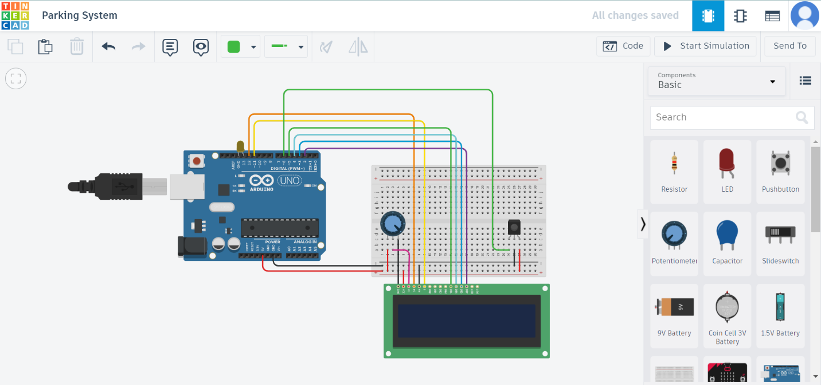

* PROGRAM

#include <LiquidCrystal.h> // Decleration the LCD header file

LiquidCrystal lcd(12, 11, 5, 4, 3, 2); //RS, E, D4, D5, D6, D7

const int IR = 6;

const int LED1 = 13;

void setup(){

lcd.clear();

lcd.begin(16,2);

lcd.setCursor(3,0);

lcd.print("IR Sensor");

lcd.setCursor(0,1);

lcd.print("MD.TAUFEEQ BASHA");

delay(500);

}

void loop(){

Sensor1();

delay(500);

}

void Sensor1(){

int statusSensor1 = digitalRead (IR);

if (statusSensor1 == 1){

digitalWrite(LED1, HIGH); // LED HIGH

lcd.setCursor(0,0);

lcd.print("Vehicle Found");

lcd.setCursor(1,1);

lcd.print("The LED IS ON ");

}

else

{

digitalWrite(LED1, LOW); // LED LOW

lcd.setCursor(0,0);

lcd.print("Object Not Found");

lcd.setCursor(0,1);

lcd.print(" The LED IS OFF ");

}

}

* Output in Tinkercad:

